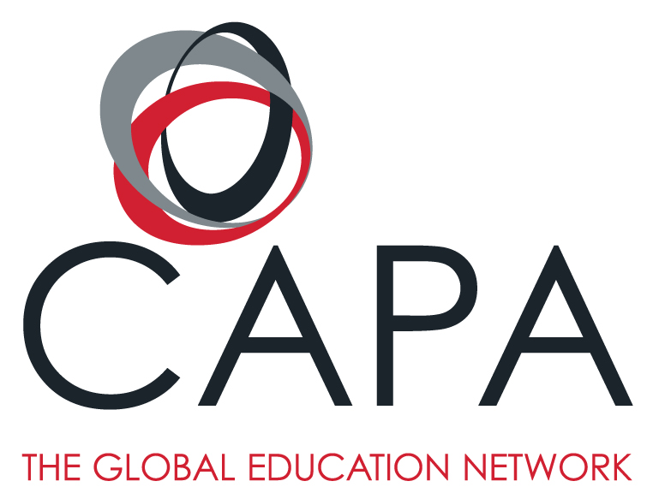

Introduction to Astronomy: British Contributions and Developments
CAPA LONDON PROGRAM

Summer 2020

Faculty name : Katrina Brown
E-mail : kwb@pitt.edu
Class times : TBD
Classroom location : TBD
Office Hours : TBD & by appointment

Course Description
This course will explore human knowledge of the solar system and of the night sky, as well as the growth of astronomy as a science. The development of astronomy in England has been influenced by many factors and represents a rich microcosm of the evolution of astronomy in the western world. British contributions to astronomy will be used to exemplify the progress and achievements of this field of science.

Throughout history astronomy has been intertwined with both time-keeping and navigation and we will explore these connections in and around London. The passage of time is manifested through the motions of the sun which we will investigate when we visit sundials throughout London. More elaborate structures, like Stonehenge (which we will discuss and visit), can be used to mark the passage of time on greater scales. The importance of astronomy to time-keeping also made it invaluable to navigation. When we visit the National Maritime Museum we will examine and discuss the instruments in their Astronomical and Navigational Collection to elucidate the link between astronomy and navigation. This link between the two areas meant that the interests of astronomers intersected with the interests of the government which led to the development of the Royal Observatory at Greenwich which we will also visit and explore. Lastly, when we visit Westminster Abbey we will see that the importance of the work of astronomers was so valued that the scientists themselves were esteemed.

Course Aims
Students will develop critical thinking skills that will allow them to examine and make sense of celestial patterns. The course aims to help students see that science is fluid and it is governed by the scientific process of questioning and testing. Students will additionally learn to appreciate the close connections to astronomy and navigation and astronomy and time-keeping and to see why these connections led to governmental interest in astronomy and how this affected British astronomers.

Requirements and Prerequisites
There are no specific requirements or prerequisites for this course.

Learning Outcomes
By the end of the course students will
- Understand current scientific explanations for the motions of celestial bodies in the solar system.
- Understand the apparent motions of the stars and changes in the nighttime and daytime skies.
- Be able to describe the different types of celestial bodies in the solar system and understand their variances.
- Value the historical and scientific connections between astronomy and navigation and between astronomy and time-keeping.
- Obtain an appreciation for the development of the field of astronomy.
- Recognize and understand Britain’s achievements in the field of astronomy including the discovery of planets, the development of telescopes and clocks, contributions to optics and the study of the electromagnetic spectrum.
- Be familiar with British astronomers (such as Newton, Flamsteed, Halley, etc.) and understand their contributions to science.

Class methodology
This course will meet twice per week. Students will learn the relevant background astronomy in the classroom and then visit sites in and around London at which we will see and discuss applications, examples, and/or continuations of the classroom material. Students should also anticipate guest lecturers.

Field Component(s): CAPA provides the unique opportunity to learn about the city through direct, guided experience. Participation in the field activity(s) for this course is required. You will actively explore the Global City you are currently living in. Furthermore, you will have the chance to collect useful information that will be an invaluable resource for the assignments in this course.

Students are strongly encouraged to participate in co-curricular program activities.

Major Assignments and grade percentage:
Weekly Quizzes: There will be one quiz per week. Quizzes will tests students’ understanding of the science of astronomy. Grade %: 30%; learning outcomes A-C, F-G

Assignments: Assignments include in-class activities, worksheets, projects and homework. Submitted materials will be graded on reasoning, correctness and completion. Grade %: 30%; learning outcomes A-C, F-G

Participation: students will be expected to participate actively in class through their written and verbal contributions. Grade %: 15%; learning outcomes A-G.

Final Exam: The final exam will be at the end of the semester and will be cumulative. Grade %: 25%; learning outcomes A-C, F-G

Assessment/Grading Policy

DESCRIPTOR | LETTER | NUMERIC | GPA
Outstanding  (High Distinction) | A | 93+ | 4.0
Excellent  (Distinction) | A- | 90 - 92 | 3.75
Very good  (High Credit) | B+ | 87 - 89 | 3.25
Good  (Credit) | B | 83 – 86 | 3.00
Good  (Credit) | B- | 80 - 82 | 2.75
Average  (Good Pass) | C+ | 77-79 | 2.25
Adequate  (Pass) | C | 73 - 76 | 2.00
Below Average  (Borderline Pass) | C- | 70-72 | 1.75
Inadequate  (Borderline Fail) | D+ | 67 - 69 | 1.25
Poor  (Fail) | D | 60 - 66 | 1.00
Poor  (Fail) | F | <60 | 0
Incomplete | I | Please see CAPA policy in the Faculty Handbook.

Dress Code
No requirements.

Course Materials
The textbook for this class, Astronomy from OpenStax, is available for free online, in web view and PDF format:
www.openstax.org/details/astronomy
Print ISBN 1938168283, Digital ISBN 1947172247

Students will also be expected to acquire and read Longitude: The True Story of a Lone Genius Who Solved the Greatest Scientific Problem of His Time, (1995), by Dava Sobel.

Weekly Course Schedule

Day 1
Topics: Astronomical distances, a tour of the Universe, heliocentric model of the solar system, scaled solar system walk, the Herschels and Uranus, Adams and Neptune, Pluto’s status
Readings: Astronomy Chpt 1.4-1.7, 12.4
Site-Exploration: Park
Day 2
Topics: The tilt of the Earth, solstices, equinoxes, seasons, the moon and its phases, eclipses
Readings: Astronomy Chpt 4.1, 4.2, 4.5, 4.7

Day 3
Topics: Celestial objects in our solar system, naked-eye astronomy, Stonehenge, calendars
Readings: Astronomy Chpt 7.1, 13.1, 14.1, 4.4
Day 4
Topics: Sundials and local noon
Site-Exploration: London sundials
Readings: Astronomy Chpt 4.3, Selected readings from the British Sundial Society

Day 5
Topics: Aristotle and Ptolemy and the geocentric model of the solar system, constellations, the Zodiac and Ophiuchus, Part 1 of astronomy and navigation
Readings: Astronomy Chpt 2.1, 2.3
Day 6
Topics: Part 2 of astronomy and navigation (astrolabes, quadrants, sextants, etc.), longitude and latitude, timekeeping and astronomy (astronomical clocks, armillary spheres, etc)
Site-Exploration: National Maritime Museum
Readings: Selected readings on astrolabes from The Smithsonian

Day 7
Topics: Longitude and latitude, telescopes
Readings: Longitude: The True Story of a Lone Genius Who Solved the Greatest Scientific Problem of His Time (Dava Sobel)
Day 8
Topics: The heliocentric model of the solar system, the work of Sir Isaac Newton
Site-Exploration: The Monument, Westminster Abbey
Readings: Astronomy Chpt 2.4, Chpt 3.1, 3.3, 3.4

Day 9
Topics: Part 1 early British astronomers and their accomplishments (including Caroline Herschel, Mary Somerville, Annie Maunder, Flamsteed, Airy, Wilkins, Halley, Herschel, etc.),
Site-Exploration: The Monument
Day 10
Topics: Part 2 early British astronomers and their achievements, The Astronomers Royal, The Royal Observatory at Greenwich
Site-Exploration: The Royal Observatory

Day 11
Topics: The EM spectrum, line spectra, British contributions to spectroscopy (including Melvill, Wollaston, Lockyer, Newton and Maxwell), radio telescopes, External speaker on Jocelyn Bell and pulsars
Readings: Astronomy Chpt 5.1-5.5, 6.4
Day 12
Topic: External speaker on Stephen Hawking and black holes, final exam

Attendance, Participation & Student Responsibilities

Attendance: CAPA has a mandatory attendance policy. Attendance is taken at the beginning of every class. Unauthorized absence from class will result in a reduction of the final grade and potentially a failure for the course.

Missing classes for medical reasons: If you need to miss a class for medical reasons or for a family emergency, you must send an e-mail to let the Director of Academic Affairs (DAA) know at least one hour in advance of your class or meeting at the following e-mail:____________. Note that calling the CAPA Center (___________) is acceptable only if you do not temporarily have access to the internet. An e-mail is still required as quickly as you can get access to the internet again. You will need to provide evidence of the reason for your absence. Unexcused absences will result in a grade reduction. In the event of a missed class or field trip, it is your responsibility to contact your instructor and make up any missed assignments.

Class Participation: Students must read assignments BEFORE the class, and come to class on time. Students are expected to participate actively in group and class discussions, and the participation portion of the class will be graded accordingly. Students will often work in groups and the groups will be expected to provide verbal and/or written answers to questions during class. Students will be graded on their contribution to, and participation in, the work of the group. When individual work is required, each student must submit his/her own individually completed, novel work.

Academic Integrity: A high level of responsibility and academic honesty is expected. Because the value of an academic course depends upon the absolute integrity of the work done by the student, it is imperative that a student demonstrates a high standard of individual honor in his or her scholastic work and class behavior. Students assume full responsibility for the content and integrity of the academic work they submit. Students should not represent the work of others as their own, use or obtain unauthorized assistance in any academic work, give unauthorized assistance to other students, or modify graded work for the purpose of obtaining additional credit. Violations of academic integrity will result in dismissal from the program. See the Handbook of CAPA Academic Policies for more information and resources on plagiarism.

Use of electronic equipment in class: All devices such as laptops, I-pods, I-pads, netbooks, notebooks and tablets, smartphones, cell phones, recorders, smartwatches, etc. are NOT allowed unless you have express permission from the faculty or you have been instructed to do so. If you require an accommodation to use any type of electronic equipment, inform the Director of Academic Affairs at the beginning of Term.

Use of Electronic Translators: In Language courses students are NOT allowed to use electronic translators for writing texts in the target language: those submitting compositions and texts of whatever kind translated in such a fashion will receive a final F grade for the course.

Late Submission: Late submission of any materials collected by the instructor, either as homework or collected during class, is only permitted with prior approval. A request must be made to the relevant Faculty member no later than two days prior to the due date. Late submission without prior approval will result in a full letter grade penalty. In either case, work cannot be submitted after feedback has been provided to the rest of the class on the relevant assessment or one week after the due date whichever comes first, after which point a grade of F will be given for the assessment.

Behavior during Examinations: During examinations, you must do your own work. Unless specifically instructed by the lecturer or instructor, talking during an exam is not permitted, nor may you compare papers, copy from others, or collaborate in any way. Any failure to abide by examination rules will result in failure of the exam, and may lead to failure of the course and disciplinary action.

